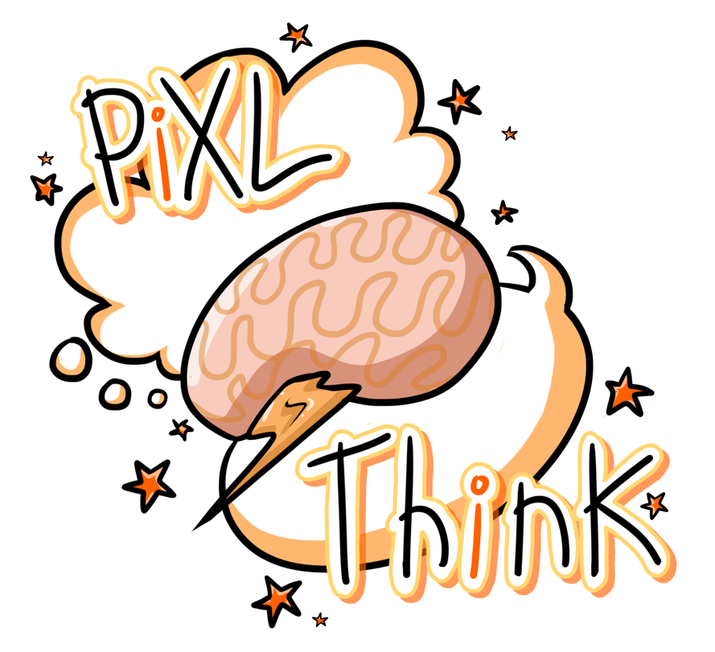

PiXL Revisit
A Strategy for Revision

PiXL Revisit – a strategy for revision.

The increased complexity and content of the newly reformed GCSE and A Level exams means that effective revisiting is essential if our students are to achieve academic success.
So how can we ensure our students are working effectively outside of the classroom? What does good revisiting look like? The newly reformed exams mean that students will have to recall greater amounts of facts and knowledge quickly. While rote learning and regurgitating content doesn’t lead to deep thinking, we know that firstly the information needs to go in, through memorisation of key facts. Fundamental knowledge needs to be embedded, even imprinted on the minds of students to facilitate quick and easy recall. Next students need to deepen their knowledge through higher-order thinking as information learned and processed through higher-order thinking processes is remembered longer and more clearly than information that is processed through lower-order, rote memorisation. Finally, students need to retrieve, demonstrate, apply and test their learning.
This pack contains templates we have produced to help our students break down large amounts of knowledge into manageable chunks, make sense of this information and recall it when needed.
It also includes a calendar to enable our students to be more independent in their revision. The calendar suggests that students set out the topics they will revisit each day, and then self-assess how well thay can recall that topic at the end of the session.

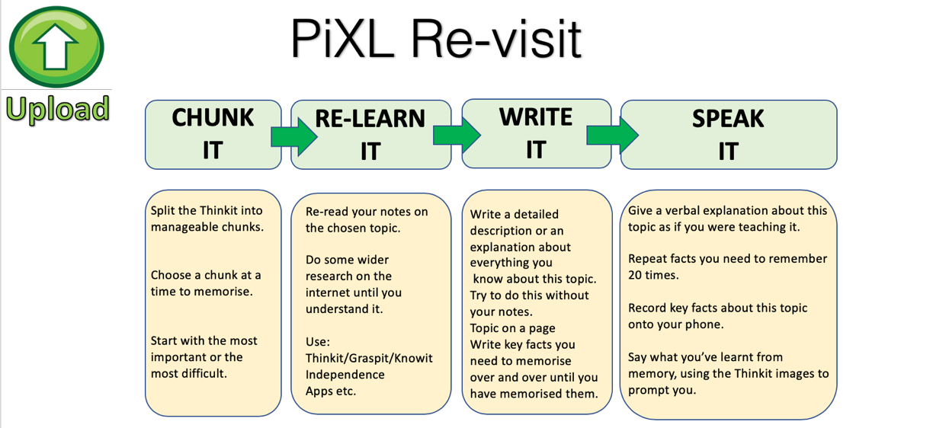

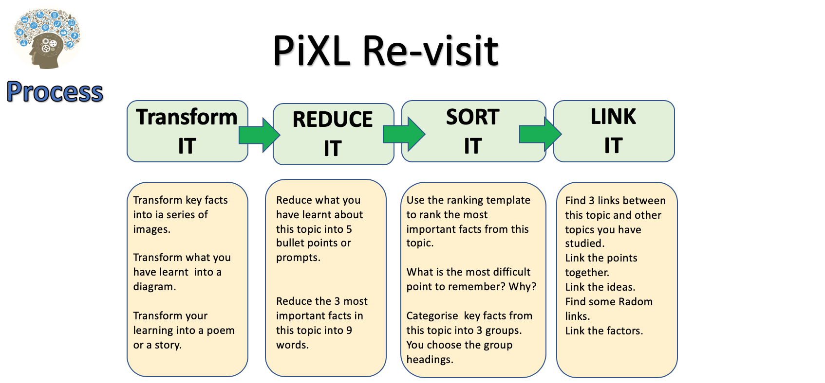

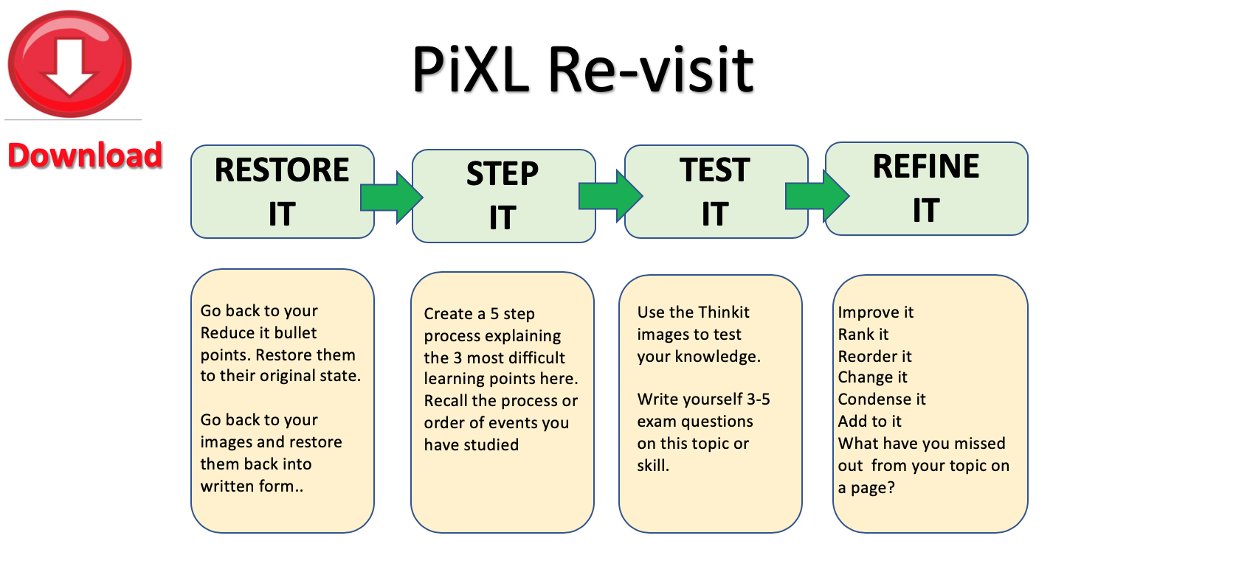

PiXL Revisit: Reduce and Transform
Unit / Topic:

1.

2.

3.

4.

5.

Unit / Topic:
PiXL Revisit: Prioritise - Significance and Importance
5.

3.

1.
Notes:

WHY?

WHY?
Key Facts, Dates, Words, Vocab:
Number of Priority:

WHY?

WHY?
2.

4.

WHY?

PiXL Revisit: 3 x 2 Testing
Unit / Topic:

Last Lesson
Key facts:
Last Week
Key facts:
Last Year
Key facts:
One topic to revise next:

PiXL Revisit: Process and Categorise
Steps and stages explained

Unit / Topic:

Which is the most important stage?

WHY?

Key Facts / Observations

PiXL Revisit: Chunk It
Unit / Topic:

10
Chunks of learning of this / topic / area
* You could start with the most important or the most difficult to learn

1.
2.
3.
4.
5.
6.
7.
8.
9.
10.

PiXL Revisit: Ranking Triangle

Name of Topic: __________________________________________________________________________________________________
Name: __________________________________________________________________________________________________
Class: __________________________________________________________________________________________________

The most important information goes at the top and then the least important at the bottom. Make sure you justify WHY you think it the most/least important.
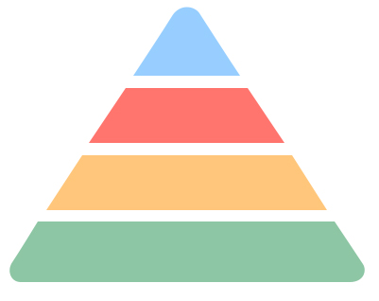

_______________________________________________________________________________________________________________________________________________________________________________________________________________________________________________________________________________________________________________________________________________________________________________________
PiXL Revisit: Thinking Hard Model

Name of Topic: __________________________________________________________________________________________________
Name: __________________________________________________________________________________________________
Class: __________________________________________________________________________________________________

Take a section of the text and do the following:

- Prioritise: Underline the three most important sentences here. Rank 1-3, briefly explain number 1. Cross out the least important sentence

- Reduce: Reduce the key information into 12 words

- Transform: Transform this information into 4 pictures or images (no words allowed)

- Categorise: Sort this information into three categories. Highlight and think of a suitable title for each category.

- Extend: Write down three questions you’d like to ask an expert in this subject.

PiXL Revisit: ‘Boxing Up’ Activity

Name of Topic: __________________________________________________________________________________________________
Name: __________________________________________________________________________________________________
Class: __________________________________________________________________________________________________

Read the text and then put your thoughts in to different boxes so that you have ‘boxed up’ the text.

Box 1 – 3 things I did not know

Box 2 – 3 things I understand better now

Box 3 – 3 things I already knew

PiXL Revisit: Question Time

Name of Topic: __________________________________________________________________________________________________
Name: __________________________________________________________________________________________________
Class: __________________________________________________________________________________________________
When you read any text, you should be asking it questions NOT just letting it wash over you. Read your text and pause and ask it questions - e.g. ‘what do you mean when you say ‘….”?’

Questions I’m asking the text |  | Answers to those questions |  | Things I need to ask my teacher
PiXL Revisit: Quizzing

Name of Topic: __________________________________________________________________________________________________
Name: __________________________________________________________________________________________________
Class: __________________________________________________________________________________________________
Read the text and come up with 20 questions to ask someone about the text.
 | Question | Answer
1
2
3
4
5
6
7
8
9
10
11
12
13
14
15
16
17
18
19
20

PiXL Revisit: Transforming

Name of Topic: __________________________________________________________________________________________________
Name: __________________________________________________________________________________________________
Class: __________________________________________________________________________________________________
Turn the material you have read into up to 6 pictures – one per paragraph or one per key piece of information. The pictures must represent the information so that they can act as a reminder of what the text said. Underneath each picture, explain your thinking.

1. | 2. | 3.
4. | 5. | 6.

Now restore your pictures back into its original form.

Chapter theme / topic
Main idea 1
Specific detail A
Specific detail B
Specific detail C
Main idea 2
Specific detail D
Specific detail E
Specific detail F
Specific detail G
Specific detail H
Specific detail I
Specific detail J
Specific detail K
Specific detail K
Main idea 4
Main idea 3

Taken from the article: ‘What Will Improve a Student’s Memory?’ By Daniel T Willingham (http://www.aft.org/sites/default/files/periodicals/willingham_0.pdf)

Taken from the article: ‘What Will Improve a Student’s Memory?’ By Daniel T Willingham (http://www.aft.org/sites/default/files/periodicals/willingham_0.pdf)
PiXL Revisit: Transform
Unit / Topic:

Key Points

1.
2.
3.
4.
5.
6.
7.
8.
9.
10.

PICTURE/ SOURCE/ INFO/ RESOURCE

Most important + WHY:

PiXL Revisit: Examine It

Key Dates
Exam Question
NOTES
Topic:
1.
2.
3.
4.
5.
6.
Key Facts
Key Quotes
Key Formulae
Key Words

PiXL Revisit: Flexibility of thinking Connection Map

Title

PiXL Revisit: Flexibility of thinking Connection Map
Draw lines linking the boxes. The darker /stronger the line the stronger the link.
Title
Place the information/ factors/knowledge in the boxes. Add as many boxes as you want to.

On the line give reasons for the links - explain the LINK /importance or significance.

You could also add formula/dates/facts/quotes near or on the line to exemplify knowledge

PiXL Revisit: Experiment on a page
Experiment Title:

Process / Method

1.
2.
3.
4.
5.
6.
7.
8.
9.
10.

Formulae
Label
Label
Label
Experiment Diagram
Results

PiXL Revisit: Transform
Unit / Topic:
Picture
NOTES:

Picture

PiXL Revisit: Reduce to 6 points
Unit / Topic:

Information

Information
Reduce to 6 points

1.
2.
3.
4.
5.
6.
Prioritise (most important)

1.
2.
3.
4.
5.
6.

WHY?
P
R
I
O
R
I
T
I
S
E

Reduce to 3 key points

A.

B.

C.
R
E
D
U
C
E

Monday | Tuesday  PiXL Revisit: Chunk It Revision Timetable | Wednesday | Thursday | Friday
19 October 2020  Not sure OK Great!  I must recap:  Page number: | 20 October 2020  Not sure OK Great!  I must recap:  Page number: | 21 October 2020  Not sure OK Great!  I must recap:  Page number: | 22 October 2020  Not sure OK Great!  I must recap:  Page number: | 23 October 2020  Not sure OK Great!  I must recap:  Page number:
19 October 2020  Not sure OK Great!  I must recap:  Page number: | 20 October 2020  Not sure OK Great!  I must recap:  Page number: | 21 October 2020  Not sure OK Great!  I must recap:  Page number: | 22 October 2020  Not sure OK Great!  I must recap:  Page number: | 23 October 2020  Not sure OK Great!  I must recap:  Page number:
Monday | Tuesday  PiXL Revisit: Chunk It Revision Timetable | Wednesday | Thursday | Friday
26 October 2020  Not sure OK Great!  I must recap:  Page number: | 27 October 2020  Not sure OK Great!  I must recap:  Page number: | 28 October 2020  Not sure OK Great!  I must recap:  Page number: | 29 October 2020  Not sure OK Great!  I must recap:  Page number: | 30 October 2020  Not sure OK Great!  I must recap:  Page number:
26 October 2020  Not sure OK Great!  I must recap:  Page number: | 27 October 2020  Not sure OK Great!  I must recap:  Page number: | 28 October 2020  Not sure OK Great!  I must recap:  Page number: | 29 October 2020  Not sure OK Great!  I must recap:  Page number: | 30 October 2020  Not sure OK Great!  I must recap:  Page number:
PiXL Revisit: Chunk It Revision Timetable

Monday | Tuesday | Wednesday | Thursday | Friday
2 November 2020  Not sure OK Great!  I must recap:  Page number: | 2 November 2020  Not sure OK Great!  I must recap:  Page number: | 2 November 2020  Not sure OK Great!  I must recap:  Page number: | 2 November 2020  Not sure OK Great!  I must recap:  Page number: | 2 November 2020  Not sure OK Great!  I must recap:  Page number:
2 November 2020  Not sure OK Great!  I must recap:  Page number: | 2 November 2020  Not sure OK Great!  I must recap:  Page number: | 2 November 2020  Not sure OK Great!  I must recap:  Page number: | 2 November 2020  Not sure OK Great!  I must recap:  Page number: | 2 November 2020  Not sure OK Great!  I must recap:  Page number:
9 November 2020  Not sure OK Great!  I must recap:  Page number: | 10 November 2020  PiXL Revisit: Chunk It Revision Timetable  Not sure OK Great!  I must recap:  Page number: | 11 November 2020  Not sure OK Great!  I must recap:  Page number: | 12 November 2020  Not sure OK Great!  I must recap:  Page number: | 13 November 2020  Not sure OK Great!  I must recap:  Page number:
9 November 2020  Not sure OK Great!  I must recap:  Page number: | 10 November 2020  Not sure OK Great!  I must recap:  Page number: | 11 November 2020  Not sure OK Great!  I must recap:  Page number: | 12 November 2020  Not sure OK Great!  I must recap:  Page number: | 13 November 2020  Not sure OK Great!  I must recap:  Page number:
16 November 2020  Not sure OK Great!  I must recap:  Page number: | 17 November 2020  PiXL Revisit: Chunk It Revision Timetable  Not sure OK Great!  I must recap:  Page number: | 18 November 2020  Not sure OK Great!  I must recap:  Page number: | 19 November 2020  Not sure OK Great!  I must recap:  Page number: | 20 November 2020  Not sure OK Great!  I must recap:  Page number:
16 November 2020  Not sure OK Great!  I must recap:  Page number: | 17 November 2020  Not sure OK Great!  I must recap:  Page number: | 18 November 2020  Not sure OK Great!  I must recap:  Page number: | 19 November 2020  Not sure OK Great!  I must recap:  Page number: | 20 November 2020  Not sure OK Great!  I must recap:  Page number:

