Login Session
- Log on to computer
- Hand out login details (attached to bulletin)
- Stick log in detail in planners
- Open Google Chrome browser
Email address
IMPORTANT: YOU MUST USE SHIFT TO WRITE CAPS RATHER THAN Caps Lock FOR YOUR PASSWORD
Password

How to change your password
Once logged in you can change your password, if you choose to change your password, ensure it is IDENTICAL TO YOUR SCHOOL PASSWORD which you used to log into this computer.

Details on next page

Directions to change password
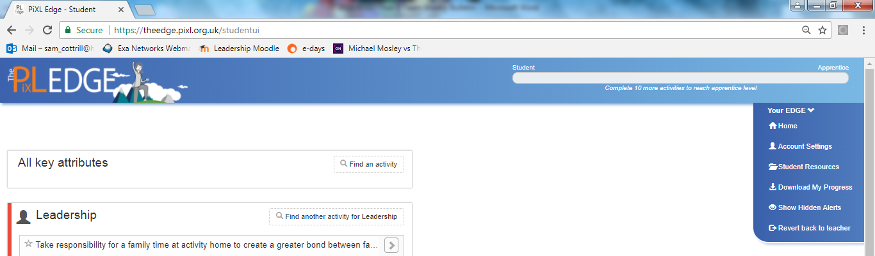
Click on Account Settings

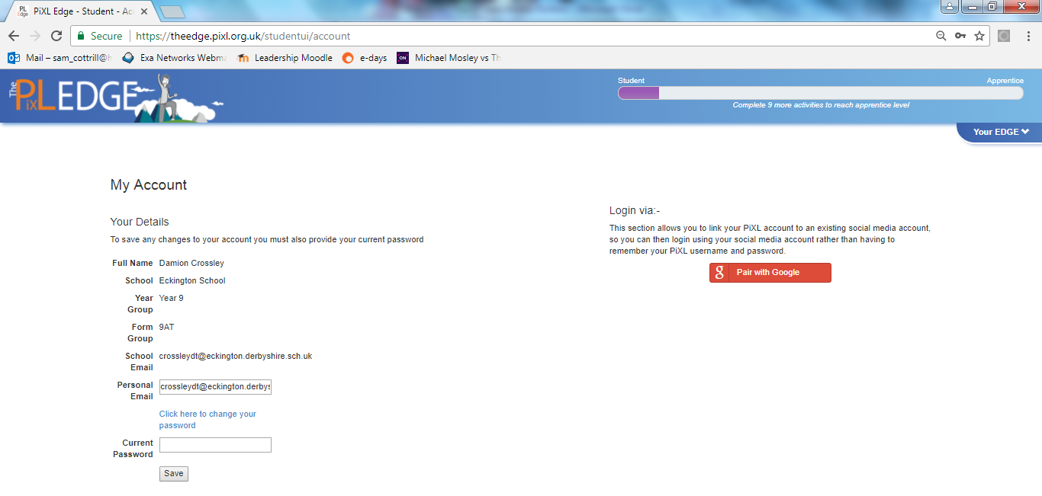
Click here to change password

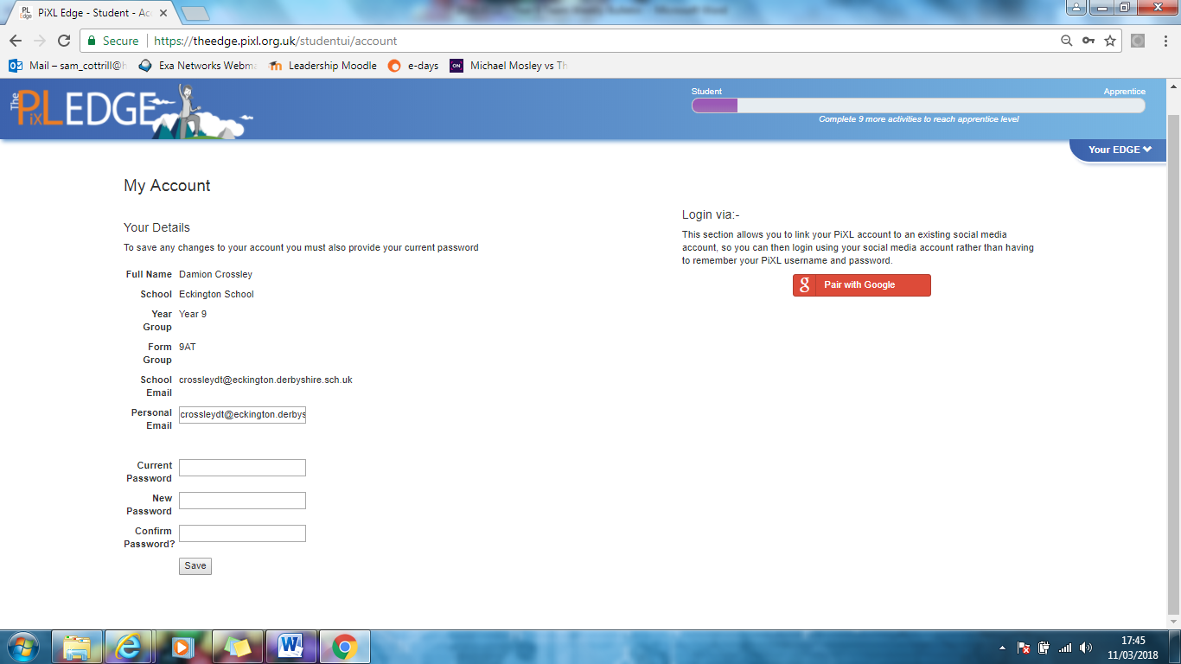
If there is no personal email, copy and paste your school email into here
Carefully write in your school password
Type original password

