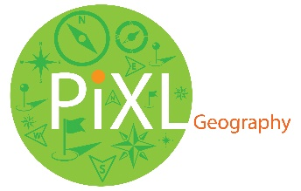**­­**



**PiXL Gateway: Progression - Geography**

**Contents:**

1. Introduction
2. ‘Scrap book challenge’
3. Things to read or watch and places to go
4. Topic based task – photograph analysis
5. Topic based task – the big questions
6. **Introduction**

It is great that you are considering studying Geography at A Level.

This pack contains a set of tasks and resources to prepare you to start an A Level in Geography. It should be used after you complete your GCSE, throughout the remainder of the summer term and over the summer holidays to ensure you are ready to start your course in September.

The pack will touch on a range of key topic areas and some skills linked to A level Geography: Coasts, Water Cycle, Hazards, Globalisation, Population, Urban Environments and Changing Places.

*“****The study of geography is about more than just memorising places on a map. It is about understanding the complexities of the world, appreciating the diversity of cultures that exist across continents. And in the end, it is about using all that knowledge to help bridge divides and bring people together.”*** Barack Obama.

1. **‘Scrap book challenge’**

**TASK 1:** Before you start your A level geographical studies you could try to complete the ‘**Geographical scrap books**’. You could create two separate books, one for human geography and one for physical geography. You should collect relevant news clips, photographs and articles etc. These snippets of geography can then be used to support your answers in your exams. Aim for at least three bits of information in each book.

1. **Things to read or watch and places to go**

**Things to read or watch**

**Some good general geography sources:**

Geography Review: <http://www.philipallan.co.uk/geographyreview/index.h>tm

Geographical: <http://www.geographical.co.uk/Home/index.html>

Factfulness: Ten Reasons We're Wrong About the World – and Why Things Are Better Than You Think. By Hans Rosling, Ola Rosling, Anna Rosling Rönnlund

Useful websites: <http://www.nationalgeographic.com/>

<http://www.geographyalltheway.com> <http://www.gatm.org.uk>

**More specific articles and lectures that will broaden your geographical knowledge and understanding.**

DON'T PANIC — Hans Rosling showing the facts about population <https://www.youtube.com/watch?v=FACK2knC08E&t=1583s>

Interactive map of coastal map of the UK coastline

<https://www.gov.uk/check-plans-to-stop-coastal-erosion-in-your-area>

What is happening to the plates?

<https://www.newscientist.com/article/mg22329843-000-earths-tectonic-plates-have-doubled-their-speed>

How can technology improve a country’s vulnerability?

<https://www.ted.com/talks/paul_conneally_digital_humanitarianism>

What is a ‘global sense of place’? Why is this important to the understanding of ‘place’ as a concept? Massey, D (1991) <http://banmarchive.org.uk/collections/mt/pdf/91_06_24.pdf>

**Places to go**

If you visit any interesting places over the holidays take geographical photographs of the area. Build up a photographic record for the area. It does not need to be a place far from home, it could be in your local area. Consider; what is the physical geography of the area? How is the physical environment influenced by human activity? What geographical investigation could be carried out in this area?

**TASK 2:** Produce a report to share with your new class in September on one of the areas listed above. So, when you read an article, remember to jot down a few notes on what you learned from it. If you visit a place, take some photographs and be ready to explain the geography that you have experienced.

1. **Topic based task – photograph analysis – THINK!**

In Geography it is vital that you learn how to use photographs effectively.

**TASK 3:** Study the images provided and annotate them to show your knowledge and understanding. Use the prompts to help you.

**Physical Geography: coasts.**

**Prompts.** Think about; coastal processes, coastal features, threats, management, human uses and what might happen in the future?

A beach in the Algarve, Portugal

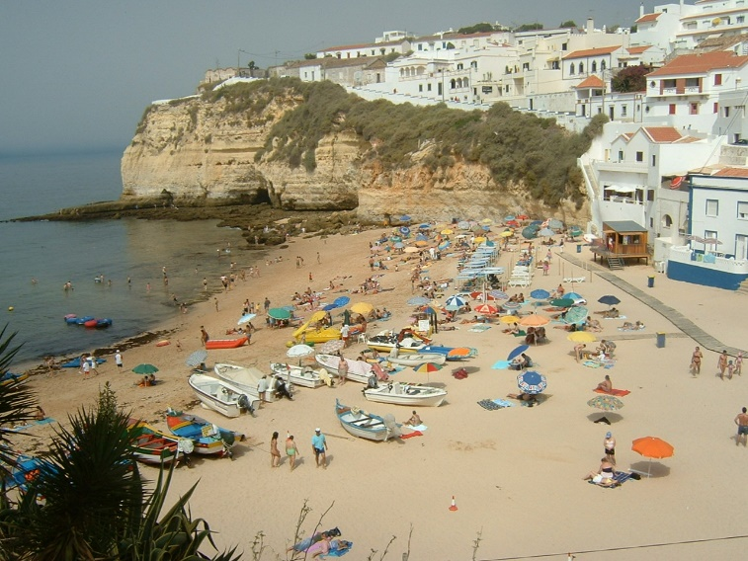

**Physical Geography: hazards**

**Prompts.** Think about; tectonic processes, threats, impacts, risks and management.

Mt Agnu. Bali. (Photography by Martina Russell-Smith)

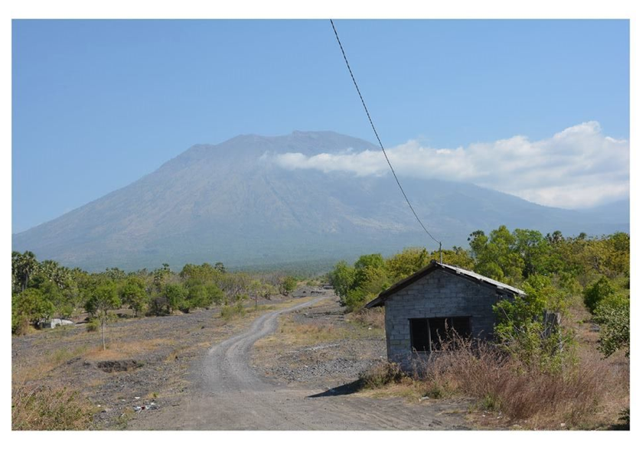

**Human Geography: Changing Places**

**Prompts.** Think about; character of place, media representation of place, how and why this area developed, how it has changed over time, the reasons for regeneration and relative success of the regeneration.

London Docklands, London, England

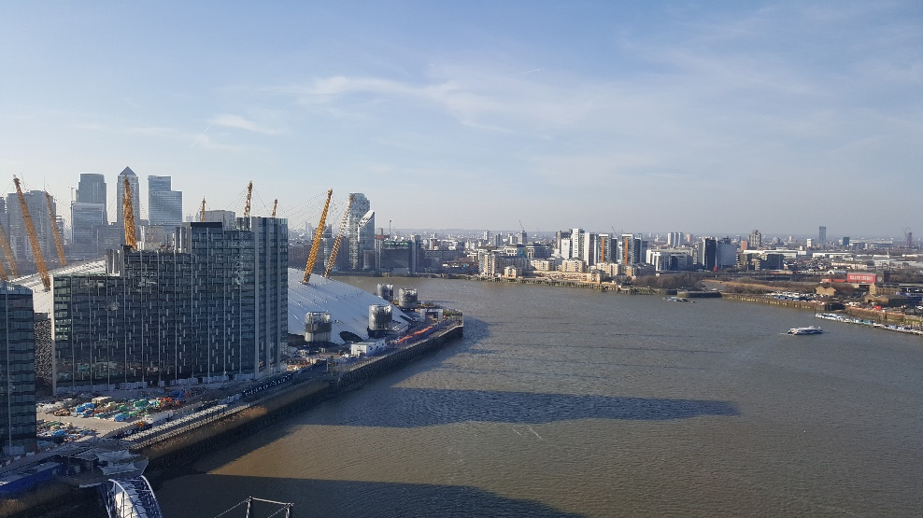

**Human Geography: Globalisation**

**Prompts.** Think about; character of place, media representation of place, how might this place link to the global market? How is this place linked to globalisation? Where does this place fit into global governance?

A market place on Mahe, in the Seychelles.

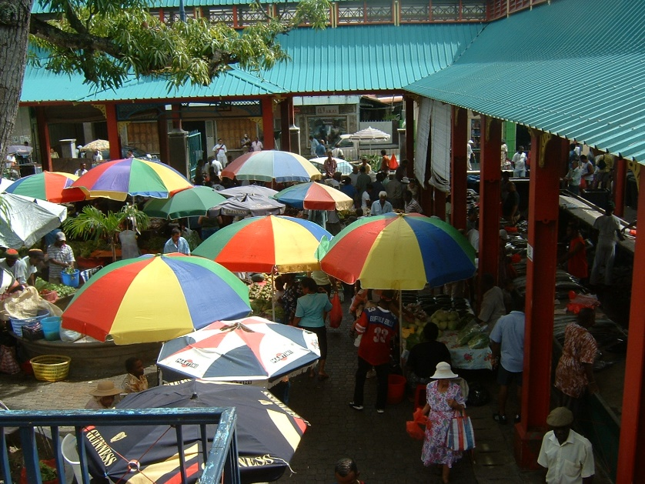

**V. Topic based task – ‘the big questions’**

When studying geography it is important to be aware of the ‘big questions’ that impact upon our world today. Below is a set of ‘big questions’ for you to consider.

**Question 1**. ‘It is a country’s level of economic development that will determine how well it copes with natural hazards.’ Evaluate the validity of this statement.

**Question 2**. ‘Wars in the future will be fought over water.’ To what extent do you agree with this statement?

**Question 3**. ‘Globalisation is positive to all.’ To what extent do you agree with this statement?

**Question 4.** Doreen Massey’s work revolves around the concept of “*a sense of place*”. What do you consider this phrase to mean?

**Question 5.** ‘Coastal areas in developing countries are more at risk than those in developed countries.’ To what extent do you agree with this statement?

**Question 6**. Urban areas are better places to live than rural areas. Discuss.

**Question 7.** How should Antarctica be used by people in the future, if at all?

**TASK 4:** Read through these seven big questions.

For each one briefly outline what your opinion is on the ‘big question’.

Choose **one** of these big questions, expand upon your brief opinion and write your key arguments linked to this issue. Where appropriate use evidence to back up your opinions.



**© The PiXL Club Ltd. June 2018**

This resource is strictly for the use of member schools for as long as they remain members of The PiXL Club. It may not be copied, sold, or transferred to a third party or used by the school after membership ceases. Until such time it may be freely used within the member school.

All opinions and contributions are those of the authors. The contents of this resource are not connected with, or endorsed by, any other company, organisation or institution.

PiXL Club Ltd endeavour to trace and contact copyright owners. If there are any inadvertent omissions or errors in the acknowledgements or usage, this is unintended and PiXL will remedy these on written notification.