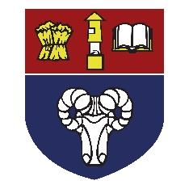
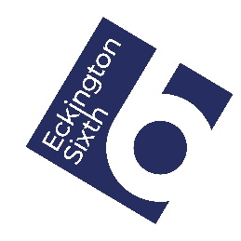
Careers Support and Guidance for Students and Parents (Summer 2020)
Dear Students,

At this difficult time you might be feeling anxious about your future options and might need to do some careers and employability skills research and development. This page contains some useful web links to sites that could help you. Please also share this with your parents / Carers.

School Website – Careers Section
Many and various links to support your careers researching on the school’s ‘Careers’ section of the website http://www.eckington.net/careers/

Careers Advice for Parents
https://successatschool.org/advicedetails
Careers Magazine for parents supporting school leavers: https://careermap.co.uk/careermag-parents/
Barclays Life skills for parents (employability support for your child): https://barclayslifeskills.com/parents

Careers Advice for Students
Searching for Careers Ideas: https://successatschool.org/careerzones
National Careers Service: https://nationalcareers.service.gov.uk/
Unifrog : Search a Careers Library https://www.unifrog.org/code
Start a MOOC (Massive Online Course) https://www.unifrog.org/student/moocs/topics
Eckington School’s BeReady Careers Site: https://live.bereadygroup.org/schools/eckington-school/
School Leavers Guides / Magazines https://careermap.co.uk/live-careermags/
Barclays employability life skills https://barclayslifeskills.com/young-people/

If you need any help and advice please get in touch. If I can’t answer the question, I can put you in touch with people who might be able to help.
Mrs Moor
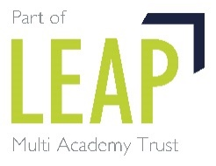
Careers Lead

