Transition Pack for A Level Physics

Get ready for A-level!
A guide to help you get ready for A-level Physics, including everything from topic guides to days out and online learning courses.

Commissioned by The PiXL Club Ltd. June 2018

© Copyright The PiXL Club Ltd, 2018

Please note: these resources are non-board specific. Please direct your students to the specifics of where this knowledge and skills most apply.
This resource is strictly for the use of member schools for as long as they remain members of The PiXL Club. It may not be copied, sold nor transferred to a third party or used by the school after membership ceases. Until such time it may be freely used within the member school.

All opinions and contributions are those of the authors. The contents of this resource are not connected with nor endorsed by any other company, organisation or institution. www.pixl.org.uk The PiXL Club Ltd, Company number 07321607

This pack contains a programme of activities and resources to prepare you to start A level in Physics in September. It is aimed to be used after you complete your GCSE throughout the remainder of the summer term and over the summer holidays to ensure you are ready to start your course in September.

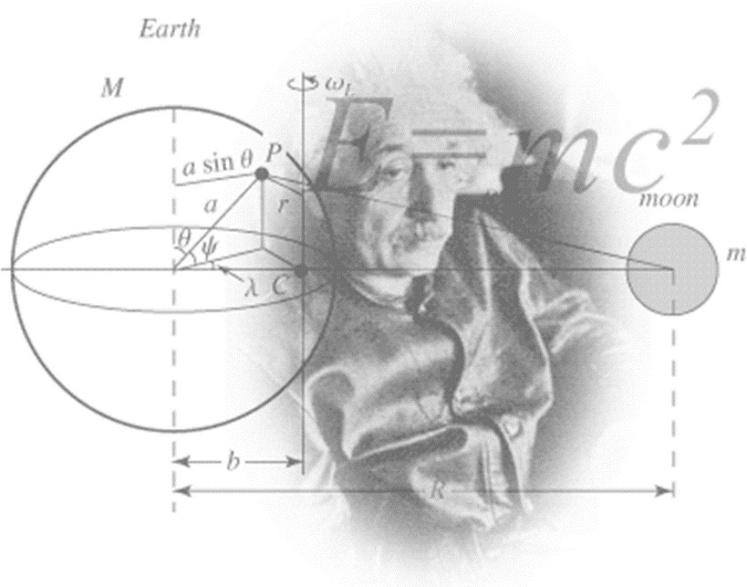

Figure 1 http://scienceworld.wolfram.com/physics/images/main-physics.gif

Below is a selection of books that should appeal to a physicist – someone with an enquiring mind who wants to understand the universe around us.

Moondust: In Search of the Men Who Fell to Earth

This book uses the personal accounts of 9 astronauts and many others involved in the space program, looking at the whole space-race era.

Surely You're Joking Mr Feynman: Adventures of a Curious Character

By reading this book you will get insight into his
life’s work including the creation of the first atomic bomb and his work in the field of particle physics.

Quantum Theory Cannot Hurt You: Understanding the Mind-Blowing Building Blocks of the Universe

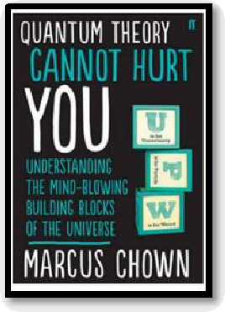Any physics book by Marcus Chown is an excellent insight into some of the more exotic areas of physics that require no prior knowledge.

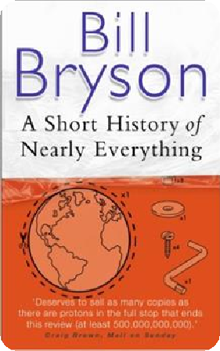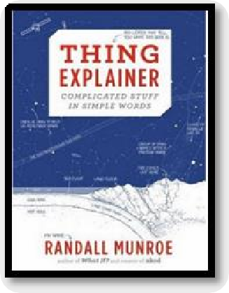A Short History of Nearly Everything

Thing Explainer: Complicated Stuff in Simple Words

Written by the creator of online comic XTCD (a great source of science humour) is a book of blueprints from everyday objects such as a biro to the Saturn V rocket and an atom bomb.

A whistle-stop tour through many aspects of history from the Big Bang to now. This is a really accessible read that will re- familiarise you with common concepts and introduce you to some of the more colourful characters from the history of science.

© Copyright The PiXL Club Ltd, 2018

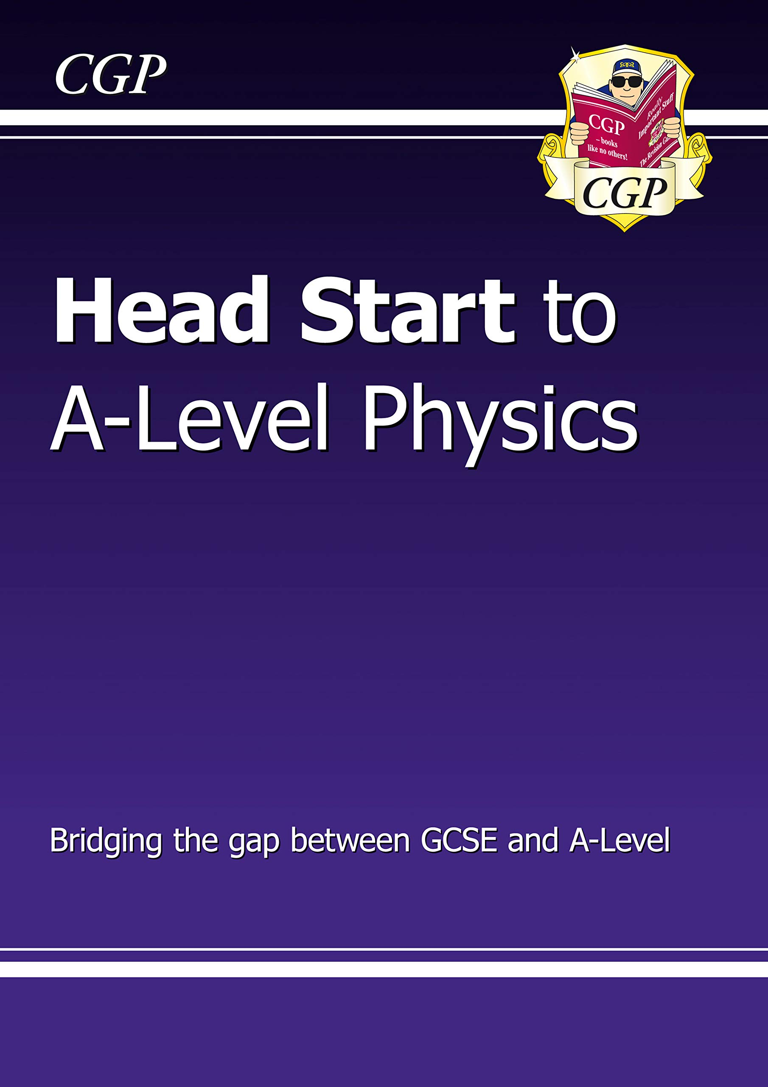

This fantastic Head Start book from CGP is the ideal way to bridge the gap between GCSE and A-Level Physics. It recaps all the crucial topics you’ll need to remember from GCSE, with crystal-clear study notes and examples, plus practice questions to test your understanding. We’ve also included introductions to some of the key topics you’ll meet at A-Level. It’s the perfect way to hit the ground running at the start of the course, whichever exam board you’re studying!

March 2020

Amazon is offering the kindle edition of this book free at the moment, if you don’t have a kindle there’s a kindle app for iPhone which allows you to read the books on there, android may have similar.

Moon (2009)
Everyone loves a good story and everyone loves some great science. Here are some picks of the best films based on real life scientists and discoveries. You wont find Jurassic Park on this list! We’ve looked back over the last 30 years to give you our top 5 films you might not have seen before. Great watching for a rainy day.

With only three weeks left in his three year contract, Sam Bell is getting anxious to finally return to Earth. He is the only occupant of a Moon-based manufacturing facility along with his computer and assistant, GERTY. When he has an accident however, he wakens to find that he is not alone.

The Imitation Game (2014)
Based on a true story. During World War II, the English mathematical genius Alan Turing tries to crack the German Enigma code with help from fellow mathematicians.

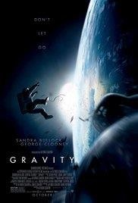

Interstellar (2014)

A team of explorers travel through a wormhole in space in an attempt to ensure humanity's survival.

Gravity (2013)

Two astronauts work together to survive after an accident which leaves them stranded in space.

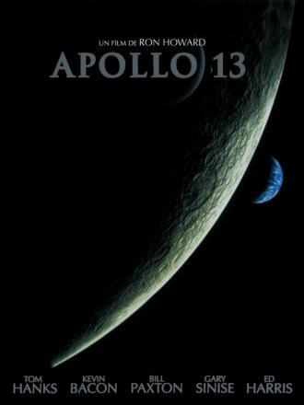
Apollo 13 (1995)

Based on a true story. NASA must devise a strategy to return Apollo 13 to Earth safely after the spacecraft undergoes massive internal damage putting the lives of the three astronauts on board in jeopardy.

There are some great TV series and box sets available too! You might want to check out: Blue Planet, Planet Earth, Wonders of the Universe, Wonders of the Solar System, NASA TV and Shock & Awe – The Story of Electricity.

If you have 30 minutes to spare, here are some great presentations (and free!) from world leading scientists and researchers on a variety of topics. They provide some interesting answers and ask some thought-provoking questions. Use the link or scan the QR code to view:

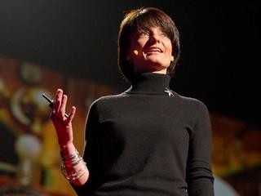
From mach-20 glider to hummingbird drone
Available at: https://www.ted.com/talks/regina_dugan_f rom_mach_20_glider_to_humming_bird_dr one/up-next?language=en
"What would you attempt to do if you knew you could not fail?" asks Regina Dugan, then director of DARPA, the Defense Advanced Research Projects Agency. In this talk, she describes some of the extraordinary projects that her agency has created.

Is our universe the only universe?
Available at: https://www.ted.com/talks/brian_greene_wh y_is_our_universe_fine_tuned_for_life?langua ge=en
Brian Greene shows how the unanswered questions of physics (starting with a big one: What caused the Big Bang?) have led to the theory that our own universe is just one of many in the "multiverse."

The fascinating physics of everyday life Available at : https://www.ted.com/talks/helen_czerski_ fun_home_experiments_that_teach_you_ physics?language=en
Physicist Helen Czerski presents various concepts in physics you can become familiar with using everyday things found in your kitchen.

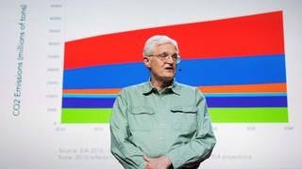
We need nuclear power to solve climate change
Available at : https://www.ted.com/talks/joe_lassiter_we_n eed_nuclear_power_to_solve_climate_chang e?language=en
Joe Lassiter is focused on developing clean, secure and carbon-neutral supplies of reliable, low-cost energy. His analysis of the world's energy realities puts a powerful lens on the touchy issue of nuclear power.

Research, reading and note making are essential skills for A level Physics study. For the
following task you are going to produce ‘Cornell Notes’ to summarise your reading.

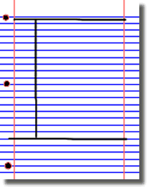
- Divide your page into three sections like this

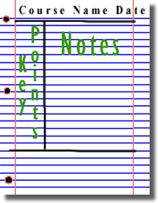
3. Use the large box to make notes. Leave a space between separate idea. Abbreviate where possible.

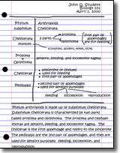
5. Write a summary of the main ideas in the bottom space
- Write the name, date and topic at the top of the page

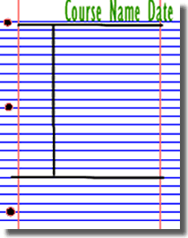
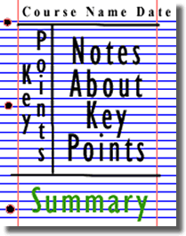
4. Review and identify the key points in the left hand box

Images taken from http://coe.jmu.edu/learningtoolbox/cornellnotes.html

Physics provides daily online-only news and commentary about a selection of papers from the APS journal collection. The website is aimed at the reader who wants to keep up with highlights of physics research with explanations that don’t rely on jargon and technical detail.

For each of the following topics, you are going to use the resources to produce one page of Cornell style notes.

Use the links or scan the QR code to take you to the resources.

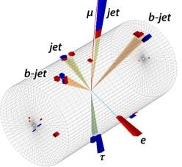
Topic 1: Sizing up the top quarks interaction with the Higgs
Available at: https://physics.aps.org/articles/v11/56 A proton collision experiment at CERN provides a
new handle on the Higgs boson’s interaction with the
heaviest of the quarks.

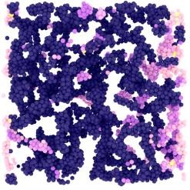
Topic 2: Why soft solids get softer

Available at: https://physics.aps.org/articles/v11/50

Soft materials like gels and creams exhibit fatigue resulting from the stretching of their constituent fibres, according to experiments and simulations.

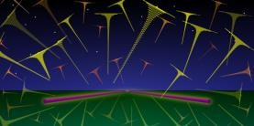
Topic 3: Listening for the cosmic hum of black holes

Available at: https://physics.aps.org/articles/v11/36

A new analysis technique would allow the gravitational-wave “background” from distant black hole mergers to be detected in days instead of years.

A level Physics will use your knowledge from GCSE and build on this to help you understand new and more demanding ideas. Complete the following tasks to make sure your knowledge is up to date and you are ready to start studying:

Symbols and Prefixes

Prefix | Symbol | Power of ten
Nano | n | x 10-9
Micro | μ | x 10-6
Milli | m | x 10-3
Centi | c | x 10-2
Kilo | k | x 103
Mega | M | x 106
Giga | G | x 109

At A level, unlike GCSE, you need to remember all symbols, units and prefixes. Below is a list of quantities you may have already come across and will be using during your A level course.

Quantity | Symbol | Unit
Velocity | v | ms-1
Acceleration | a | ms-2
Time | t | S
Force | F | N
Resistance | R | Ω
Potential difference | V | V
Current | I | A
Energy | E or W | J
Pressure | P | Pa
Momentum | p | kgms-1
Power | P | W
Density | ρ | kgm-3
Charge | Q | C

Task: Solve the following:

- How many metres in 2.4 km?
- How many joules in 8.1 MJ?
- Convert 326 GW into W.

- Convert 54 600 mm into m.
- How many grams in 240 kg?
- Convert 0.18 nm into m.
- Convert 632 nm into m. Express in standard form.
- Convert 1002 mV into V. Express in standard form.
- How many eV in 0.511 MeV? Express in standard form.
- How many m in 11 km? Express in standard form.

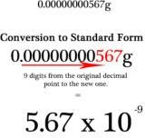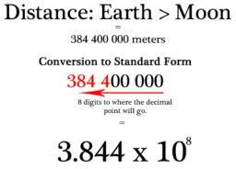Standard Form

At A level, quantities will be written in standard form and it is expected that your answers will be too.

http://www.ultimatemaths.com/standard-form-conversion.htm

This means answers should be written as ….x 10y. E.g. for an answer of 1200kg we would write 1.2 x 103kg. For more information visit: www.bbc.co.uk/education/guides/zc2hsbk/revision

Task: Complete the following problems;

- Write 2530 in standard form.

- Write 280 in standard form.

- Write 0.77 in standard form.

- Write 0.0091 in standard form.

- Write 1 872 000 in standard form.
- Write 12.2 in standard form.
- Write 2.4 x 10 2 as a normal number.
- Write 3.505 x 10 1 as a normal number.
- Write 8.31 x 10 6 as a normal number.
- Write 6.002 x 10 2 as a normal number.
- Write 1.5 x 10-4 as a normal number.
- Write 4.3 x 103 as a normal number.

Rearranging Formulae

This is something you will have done at GCSE and it is crucial you master it for success at A level. For a recap of GCSE watch the following links:

www.khanacademy.org/math/algebra/one-variable-linear-equations/old-school-equations/v/solving-for-a-variable www.youtube.com/watch?v=_WWgc3ABSj4
Task: Rearrange the following:

- E=m x g x h to find h

- Q= I x t to find I

- E = ½ m v2 to find m
- E = ½ m v2 to find v
- v = u + at to find u
- v = u + at to find a
- v2 = u2 +2as to find s
- v2 = u2 +2as to find u

Significant Figures

At A level you will be expected to use an appropriate number of significant figures in your answers. The number of significant figures you should use is the same as the number of significant figures in the data you are given. You can never be more precise than the data you are given so if that is given to 3 significant your answer should be too. E.g. Distance = 8.24m, time = 1.23s therefore speed = 6.75m/s

The website below summarises the rules and how to round correctly. http://www.purplemath.com/modules/rounding2.htm
Task: Give the following to 3 significant figures:

1. 3.4527
2. 40.691
3. 0.838991
4. 1.0247
Calculate the following to a suitable number of significant figures:

1. 63.2 ÷78.1 =
2. 39 + 78 + 120 =
3. (3.4+3.7+3.2) ÷3 =
4. 0.0256 x 0.129 =

Atomic Structure

You will study nuclear decay in more detail at A level covering the topics of radioactivity and particle physics. In order to explain what happens you need to have a good understanding of the model of the atom. You need to know what the atom is made up of, relative charges and masses and how sub atomic particles are arranged.

The following video explains how the current model was discovered www.youtube.com/watch?v=wzALbzTdnc8

Task: Describe the model used for the structure of an atom including details of the individual particles that make up an atom and the relative charges and masses of these particles. You may wish to include a diagram and explain how this model was discovered by Rutherford.

Recording Data
Whilst carrying out a practical activity you need to write all your raw results into a table. Don’t wait until the end, discard anomalies and then write it up in neat.
Tables should have column heading and units in this format quantity/unit e.g. length /mm
All results in a column should have the same precision and if you have repeated the experiment you should calculate a mean to the same precision as the data.
Below are link to practical handbooks so you can familiarise yourself with expectations.
http://filestore.aqa.org.uk/resources/physics/AQA-7407-7408-PHBK.PDF http://www.ocr.org.uk/Images/295483-practical-skills-handbook.pdf http://www.ocr.org.uk/Images/295483-practical-skills-handbook.pdf
Below is a table of results from an experiment where a ball was rolled down a ramp of different lengths. A ruler and stop clock were used.
Task: Identify the errors the student has made.

 | Time
Length/cm | Trial 1 | Trial 2 | Trial 3 | Mean
10 | 1.45 | 1.48 | 1.46 | 1.463
22 | 2.78 | 2.72 | 2.74 | 2.747
30 | 4.05 | 4.01 | 4.03 | 4.03
41 | 5.46 | 5.47 | 5.46 | 5.463
51 | 7.02 | 6.96 | 6.98 | 6.98
65 | 8.24 | 9.68 | 8.24 | 8.72
70 | 9.01 | 9.02 | 9.0 | 9.01

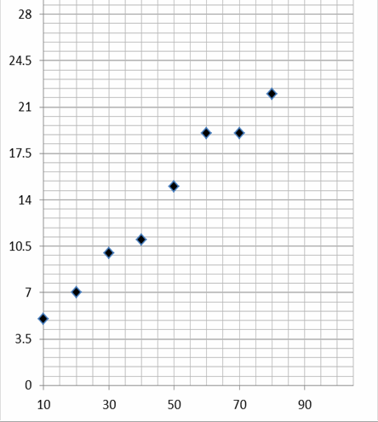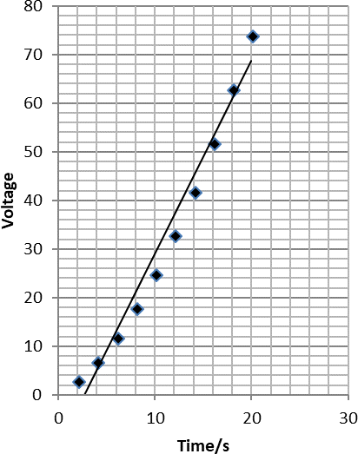

Graphs

After a practical activity the next step is to draw a graph that will be useful to you. Drawing a graph is a skill you should be familiar with already but you need to be extremely vigilant at A level. Before you draw your graph to need to identify a suitable scale to draw taking the following into consideration:

- the maximum and minimum values of each variable
- whether 0.0 should be included as a data point; graphs don’t need to show the origin, a false origin can be used if your data doesn’t start near zero.
- the plots should cover at least half of the grid supplied for the graph.
- the axes should use a sensible scale e.g. multiples of 1,2, 5 etc) Identify how the following graphs could be improved
Graph 1 Graph 2

Forces and Motion

At GCSE you studied forces and motion and at A level you will explore this topic in more detail so it is essential you have a good understanding of the content covered at GCSE. You will be expected to describe, explain and
carry calculations concerning the motion of objects. The websites below cover Newton’s laws of motion and have
links to these in action.

http://www.physicsclassroom.com/Physics-Tutorial/Newton-s-Laws

http://www.sciencechannel.com/games-and-interactives/newtons-laws-of-motion-interactive/

Task: On graph paper sketch a velocity-time graph showing the journey of a skydiver after leaving the plane to reaching the ground. Mark on terminal velocity.

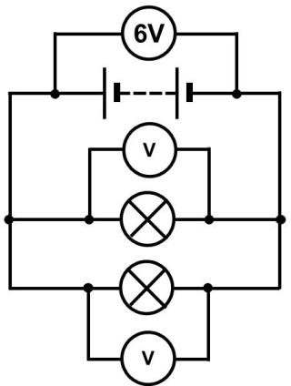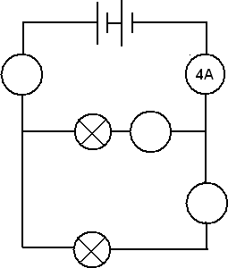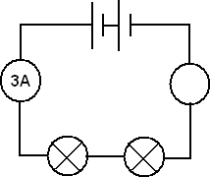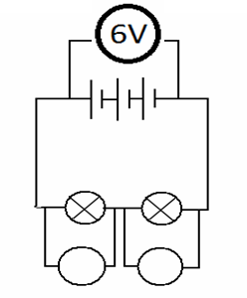
Electricity
At A level you will learn more about how current and voltage behave in different circuits containing different components. You should be familiar with current and voltage rules in a series and parallel circuit as well as calculating the resistance of a device.
http://www.allaboutcircuits.com/textbook/direct-current/chpt-1/electric-circuits/ http://www.physicsclassroom.com/class/circuits

Task:

1a) Add the missing ammeter readings on the circuits below.

b) Explain why the second circuit has more current flowing than the first.

2) Add the missing potential differences to the following circuits

Waves

You have studied different types of waves and used the wave equation to calculate speed, frequency and wavelength. You will also have studied reflection and refraction.

Use the following links to review this topic. http://www.bbc.co.uk/education/clips/zb7gkqt
https://www.khanacademy.org/science/physics/mechanical-waves-and-sound/mechanical- waves/v/introduction-to-waves

https://www.khanacademy.org/science/physics/mechanical-waves-and-sound/mechanical-
waves/v/introduction-to-waves

- Draw a diagram showing the refraction of a wave through a rectangular glass block. Explain why the ray of light takes this path.

- Describe the difference between longitudinal and transverse waves and give an example of each.

- Draw a wave and label the wavelength and amplitude.

If you are on holiday in the UK, or on a staycation at home, why not plan a day trip to one of these :

Glasgow Science Centre - Glasgow

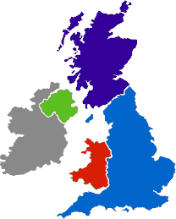Liverpool World
Museum - Liverpool

Spaceport - Wirral

Jodrell Bank Observatory - Cheshire
Kielder Observatory - Northumberland

MOSI – Museum of Science & Industry - Manchester
Alton Towers - Staffordshire

Electric Mountain - Snowdonia
Herschel Museum of Astronomy - Bath
@Bristol - Bristol The Royal Institute -
London
National Space Centre - Leicester

Royal Observatory - London

If you are on holiday in the UK, or on a staycation at home, why not plan a day trip to one of these :

Northern England and Scotland

  - Jodrell Bank Observatory – Cheshire – one of the largest moveable radio telescopes in the world and the
location of the filming of the BBC’s Stargazing Live. The site has both indoor and outdoor activities.
  - MOSI – Manchester – Massive free museum showing how science helped Britain lead the way through the industrial revolution. Contains hands on exhibits and displays and often host regular travelling exhibitions.
  - Liverpool World Museum / Spaceport – Liverpool/Wirral – Start the day off at an excellent family science museum with a top floor dedicated to astronomy including a planetarium. Take the ferry across the Mersey to another family friendly museum dedicated to spaceflight.
  - Kielder Observatory – Northumberland – Book ahead at this popular observatory in the midst of the darkest night skies the UK has to offer. Regular tours and opportunities to view the stars through professional telescopes take place on a nightly basis.
  - Glasgow Science Centre - The Centre is home to hundreds of interactive exhibits throughout the three engaging floors.

The Midlands and Wales

- Electric Mountain – Snowdonia – Set against a mountainous backdrop is a working pumped storage power station. Take a tour deep into the heart of the mountain and see the turbines spring into action to meet our ever increasing demand for electricity. Take a stroll up on of the UKs highest peaks in the afternoon.
- National Space Centre – Leicester - With six interactive galleries, the UK’s largest planetarium, unique 3D simulator experience, the award-winning National Space Centre in Leicester is an out of this world visitor attraction.
- Alton Towers – Staffordshire – Treat yourself to a go on a few rollercoasters whilst discussing Newton’s Laws. You may want to download and take these handy rollercoaster physics notes with you http://www.explainthatstuff.com/rollercoasters.html

Southern England

- Royal Observatory – London - Visit the Royal Observatory Greenwich to stand on the historic Prime Meridian of the World, see the home of Greenwich Mean Time (GMT), and explore your place in the universe at London’s only planetarium.
- Herschel Museum of Astronomy – Bath – As you walk around the picturesque Roman city – take an hour or two out at the home of one of the great scientists – discoverer of Infra-red radiation and Uranus.
- @Bristol – Bristol - home to the UK’s only 3D Planetarium and one of the biggest science centres.
- The Royal Institution – London – The birthplace of many important ideas of modern physics, including Michael Faraday’s lectures on electricity. Now home to the RI Christmas lectures and many exhibits of science history.

Science on Social Media
Science communication is essential in the modern world and all the big scientific companies, researchers and institutions have their own social media accounts. Here are some of our top tips to keep up to date with developing news or interesting stories:
Follow on Twitter:

Commander Chris Hadfield – former resident aboard the International Space Station @cmdrhadfield

NASA’s Voyager 2 – a satellite launched nearly 40 years ago that is now travelling beyond our solar system
@NSFVoyager2

Neil deGrasse Tyson – Director of the Hayden Planetarium in New York @neiltyson

The SETI Institute – The Search for Extra Terrestrial Intelligence, be the first to know what they find! @setiinstitute

Phil Plait – tweets about astronomy and bad science @badastronomer

Institute of Physics – The leading scientific membership society for physics @PhysicsNews

Scientific America – Journal sharing discoveries and insights into science that develops the world @sciam

SN Students – Science news for students @SNStudents
Find on Facebook:

National Geographic - since 1888, National Geographic has travelled the Earth, sharing its amazing stories in pictures and words.

Science News Magazine - Science covers important and emerging research in all fields of science.

BBC Science News - The latest BBC Science and Environment News: breaking news, analysis and debate on science and nature around the world.

Institute of Physics - The Institute of Physics is a leading scientific membership society working to advance physics for the benefit of all.

Chandra X-ray Observatory - NASA’s Chandra X-ray Observatory is a telescope specially designed to detect X-ray emission from very hot regions of the Universe such as exploded stars, clusters of galaxies, and matter around black holes.

Interesting Engineering - Interesting Engineering is a cutting edge, leading community designed for all lovers of engineering, technology and science.

These websites all offer an amazing collection of resources that you should use again and again
throughout your course.

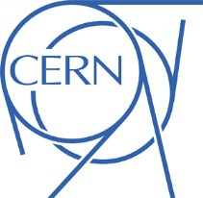

At CERN, the European Organization for Nuclear Research, physicists and engineers are probing the fundamental structure of the universe. They use the world's largest and most complex scientific instruments to study the basic constituents of matter – the fundamental particles.
https://home.cern/
physics.org is brought to you by the Physics in Society team at the Institute of Physics.
Their aim is to inspire people of all ages about physics. Let them be your guide and show you the best physics places on the web. http://www.physics.org/abou tus.asp

A website written by James Irvine, a retired teacher from Sheffield. Although the website is primarily written to support AQA, the material is also easily transferable to other exam boards. http://www.antonine-education.co.uk/

A website written by a practicing physics and maths tutor in London. @physicsandmathstutor is an Oxford physics graduate with a PGCE from Kings College London.

http://www.physicsandmaths tutor.com/

Ok, so not a website, but a YouTube channel you definitely want to watch. Y12 or AS Physics content is free to view, you will find hundreds of videos made to help you in your A Level physics studies. https://www.youtube.com/c/ALevelPh ysicsOnline

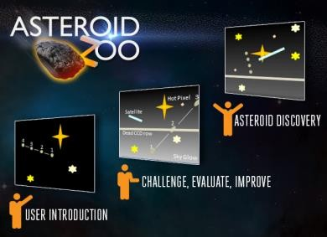
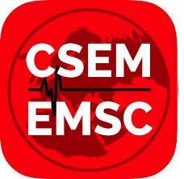
Want to stand above the rest when it comes to UCAS? Now is the time to act.
MOOCs are online courses run by nearly all universities. They are short FREE courses that you take part in. They are usually quite specialist, but aimed at the public, not the genius!
There are lots of websites that help you find a course, such as edX and Future learn.
You can take part in any course, but there are usually start and finish dates. They mostly involve taking part in web chats, watching videos and interactives.

© Copyright The PiXL Club Ltd, 2018
Day 4 of the holidays and boredom has set in?
There are loads of citizen science projects you can take part in either from the comfort of your bedroom, out and about, or when on holiday. Wikipedia does a comprehensive list of all the current projects taking place. Google ‘citizen science project’

Completing a MOOC will look great on your Personal statement and they are dead easy to take part in!

The following 40 minute test is designed to test your recall, analysis and evaluative skills and knowledge.
Remember to use your exam technique: look at the command words and the number of marks each question is worth. A suggested mark scheme is provided for you to check your answers.

A single piece of graph paper is required for the completion of the assessment. You may use a calculator.

Question  Number | Topic | Score
1 | Symbols and Prefixes | /3
2 | Standard Form | /4
3 | Re-arranging Equations | /3
4 | Atomic Structure | /3
5 | Recording Data | /3
6 | Graphing | /4
7 | Forces and Motion | /10
8 | Electrical Circuits | /5
9 | Waves | /5
 |  | Total /40

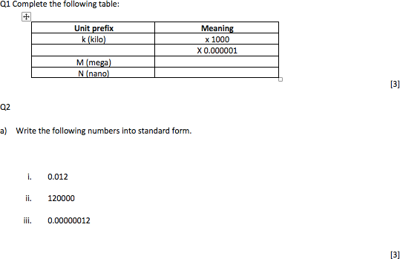

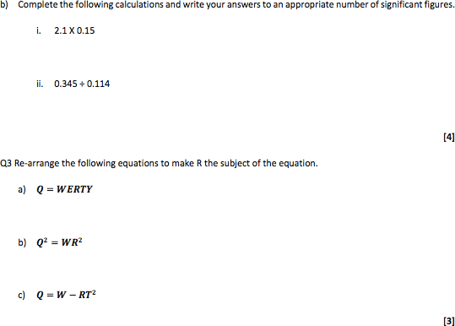

Q4

  - Name the 3 particles (from GCSE) that make up an atom.

  - Which one of the above particles is not found in the nucleus of an atom?

  - Which of the above particles will be found in varying quantities in the nuclei of isotopes of the same element?

Q5

- Complete the following table

Voltage ( ) | (A)
 | Repeat 1 | Repeat 2 | Average
2 | 0.23 | 0.26 | 0.25
4 | 0.46 | 0.53
6 | 0.69 | 0.78 | 0.74
8 | 0.92 | 1.04 | 0.98
10 | 1.15 | 1.30 | 1.23

[3]

Q6

  - Use your piece of graph paper to plot a graph of Current (x-axis) against Voltage (y-axis) drawing a line of best fit through your data points.

[4]

  - Find the gradient of your line of best fit

[3]

Q7 The graph below shows the journey of a skydiver after they have left the plane.

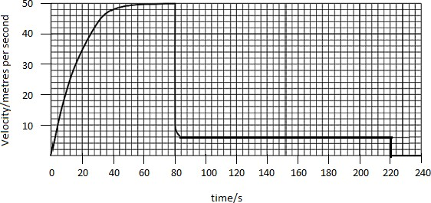
- Explain the shape of the graph commenting on how and why the forces have changed.

[6]

- Calculate the distance travelled whilst at the second terminal velocity.

[2]

- Calculate the average acceleration in the first 20 seconds.

[2]

Q8

  - Draw a circuit diagram to show how the resistance of a filament bulb could be measured using an ammeter and a voltmeter.

[2]

  - Look at the circuit diagram below. All of the resistors are identical.
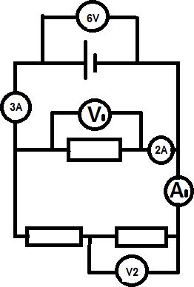

Write the missing values of current and potential difference:

    - V1 =
    - V2 =
    - A1 =

[3]

h
' PiXL,ub
partners in excellence

Q9 The image tielow shows a diagram of 2 comp1ete longitudinal wave oscillations on a s)inky:

a] State the wave1ength of the wave shown

- Label a complete wavelength on the diagram above with the correct symtiol used for wavelength in GCSE and A Level Physics

- If the above wave had a frequency of 5Hz how long would it take an individua1 hoop to complete 1 full oscil1ation?

- Calculate the speed of the wave

movespeed=/reguency xmove1enp[8

Wave speed = Unit {2)

0 Copyright The PiXL Club Ltd, 2018

A Level Physics Baseline Assessment SUGGEST MARKSCHEME
Q1

a)

Unit prefix | Meaning
k (kilo) | x 1000
μ(micro) | X 0.000001
M (mega) | x 1000000
N (nano) | x 0.000000001
[3]

Q2

- Write the following numbers into standard form i. 0.012 𝟏. 𝟐 × 𝟏𝟎^{−𝟐}
ii. 120000 𝟏. 𝟐 × 𝟏𝟎^{𝟓}
iii. 0.00000012 𝟏. 𝟐 × 𝟏𝟎^{−𝟕}

[3]
- Complete the following calculations and right your answers to an appropriate number of significant figures. i. 2.1 X 0.15
a. 0.315 = 0.32(2sf)
ii. 0.345 ÷ 0.114
a. 3.0263…=3.03 (3sf)

Award 1 mark for correct answer and 1 mark for correct number of s.f. [4] Q3 Re-arrange the following equations to make R the subject of the equation.
a) 𝑸 = 𝑾𝑬𝑹𝑻𝒀

𝑹 =
𝑸

𝑾𝑬𝑻𝒀

b) 𝑸^{𝟐} = 𝑾𝑹^{𝟐}

𝑹 =
𝑸𝟐

𝑾

c) 𝑸 = 𝑾 − 𝑹𝑻^{𝟐}

𝑹 =
𝑾 − 𝑸

𝑻𝟐

[3]

Q4

  - Name the 3 particles (from GCSE) that make up an atom

Proton, Neutron, Electron (any order) [1]

  - Which one of the above particles is not found in the nucleus of an atom?

Electron [1]

  - Which of the above particles will be found in varying quantities in the nuclei of isotopes of the same element?

Neutron [1]

Q5

a)

Voltage (V) | Current (A)
 | Repeat 1 | Repeat 2 | Average
2 | 0.23 | 0.26 | 0.25
4 | 0.46 | 0.53 | 0.50
6 | 0.69 | 0.78 | 0.74
8 | 0.92 | 1.04 | 0.98
10 | 1.15 | 1.30 | 1.23

1 Mark for correct unit (V or volts)

1 Mark for correct heading (Current in Amps or A)

1 Mark for correct average, 1 Mark if rounded to correct number of s.f.

[3]

Q6

- Use your piece of graph paper to plot a graph of Current (x-axis) against Voltage (y-axis) drawing a line of best fit through your data points.

1 mark if BOTH x and y axis cover half the graph paper 1 mark for correctly labelling x and y axis including units 1 mark if data points are correctly plotted (check 3)
1 mark for correct line of best fit (with even spread of points above and below)

[4]

© Copyright The PiXL Club Ltd, 2018

- Find the gradient of your line of best fit

Working must be shown for the award of any marks 1 mark for correct y axis read offs
1 mark for correct x axis read offs

1 mark for correct calculation of their own gradient

[3]

Q7 The graph below shows the journey of a skydiver after they have left the plane.

- Explain the shape of the graph commenting on how and why the forces have changed.

Band 1 (1/2 Marks) | Band 2 (3/4 Marks) | Band 3 (5/6 Marks)
Correctly describes the motion of the parachutists. E.g. Acceleration (at reducing rate) Terminal velocity/constant speed, deceleration, lower terminal velocity. There may be small errors in spelling and grammar. | Correctly describes motion and links to the balancing and unbalancing of the forces of weight and drag. Almost faultless spelling and grammar. | Explains why increasing velocity produces increased drag and why opening the parachute produces increase drag, using ideas of collisions of air particles with the surface of the skydiver/parachute.  Faultless spelling and grammar
[6]

- Calculate the distance travelled whilst at the second terminal velocity.

220𝑠 − 84𝑠 × 6𝑚𝑠⁻¹ = 816𝑚

[2]

- Calculate the average acceleration in the first 20 seconds.

Award 1 mark for correct unit [2]

Q8

  - Draw a circuit diagram to show how the resistance of a filament bulb could be measured using an ammeter and a voltmeter.

Award 1 mark for correctly positions ammeter [1] and voltmeter [1]
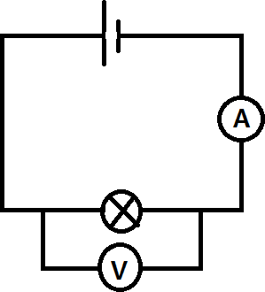

[2]

  - Look at the circuit diagram below. All of the resistors are identical.

Write the missing values of current and potential difference:

    - V1 = 6V
    - V2 = 3V
    - A1 = 1A

[3]

PiXL ub
partners in excellence

Q9 The image below shows a diagram of 3 complete longitudinal wave oscillations on a slinky:

- State the wavelength of the wave shown

Label a complete wavelength on the diagram above with the correct symbol used for wavelength in GCSE and A Level Physics

[1]

- If the above wave had a frequency of 5Hz how long would it take an individual hoop to complete 1 full oscil1a tion?

d] Calculate the speed of the wave

ivnrespeed = frequency x ivnreiength

Wave speed = Unit [2]

0 Copyright The PiXL Club Ltd, 2018

© The PiXL Club Ltd. June 2018
This resource is strictly for the use of member schools for as long as they remain members of The PiXL Club. It may not be copied, sold, or transferred to a third party or used by the school after membership ceases. Until such time it may be freely used within the member school.

All opinions and contributions are those of the authors. The contents of this resource are not connected with, or endorsed by, any other company, organisation or institution.

PiXL Club Ltd endeavour to trace and contact copyright owners. If there are any inadvertent omissions or errors in the acknowledgements or usage, this is unintended and PiXL will remedy these on written notification.

