Massive Open Online Courses (MOOCs)
During the school closure, it is a great idea to keep learning. This will give you a focus, it will strengthen your ability to transition into Year 12 or Year 13, and it will improve your skills and knowledge in a subject field that interests you.
Your teachers will have set you work to complete during this time. For Year 11 students moving into the Sixth Form, there are units of bridging work to prepare for A Level and other level 3 courses; for Year 12 students moving into Year 13, there will no doubt be plenty of exam questions, essays and assigned reading or research to do. However, if you want more – and why wouldn’t you! – there are Massive Open Online Courses or MOOCs to consider.
A MOOC is a free, online unit of study. They last anywhere from two to three weeks to six weeks or more. They come in a wide range of topics, from business or law, to history or literature; from computing, science or engineering, to nature, the environment or healthcare; from psychology or sociology to politics and government.
There are many MOOC providers. We recommend Future Learn at futurelearn.com

To give you an idea of the range of courses available:
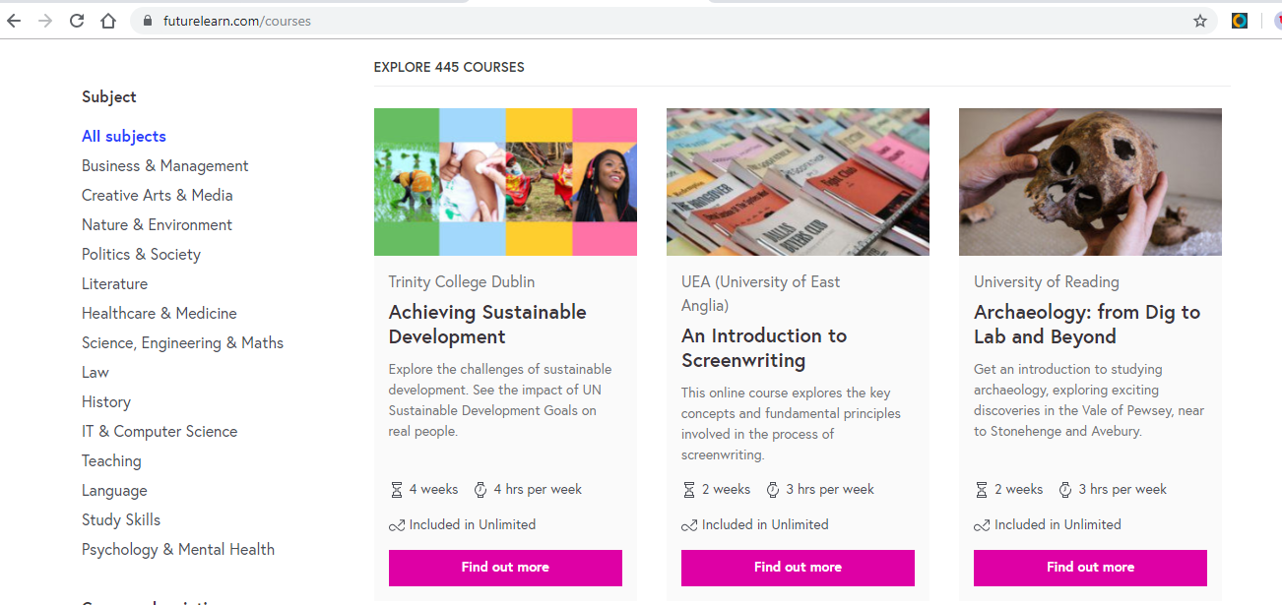

All the courses provided by Future Learn are free. There are options to pay for upgrades to unlimited access, but we do not recommend this: there is no need.
So, what’s stopping you? Use this lengthy period of free time to learn new skills and knowledge in a subject that matters to you.

MOOC: Frequently Asked Questions
The main things you need to know about this educational phenomenon:
- MOOCs help you learn online for free
- MOOCs are flexible so fit around your life
- MOOCs connect you with top UK educators and international learners.
Still curious? We hope to answer any questions you have about MOOCs below.
Q: What is a MOOC? Definition of MOOC.
A Massive Open Online Course (MOOC) is an interactive step-by-step course aimed at reaching an unlimited number of participants worldwide to create a community of lifelong learners.
Q: Why study a Massive Open Online Course (MOOC)?
Is there a niche topic you've always been interested in, but never had an opportunity to explore it? Studying in sync with thousands of online learners has massive benefits. As a MOOC Learner, you will build upon your knowledge of a special interest subject. Your CV will grow with extra-curricular initiative. Plus, employers will notice your commitment to Continuing Professional Development.
Q: How much does a MOOC cost?
Most MOOCs are free of charge.
Q: What does a MOOC look like?
Nothing like it sounds! All MOOCs are available on the FutureLearn website platform, which is very easy to use. Learners have 24:7 access to traditional course materials, such as readings and problem sets, plus interactive tools, such as videos, quizzes, user forums, social media chats and articles that all generate discussion and debate.
Q: Who can study a MOOC?
Each course is open to anyone with internet access across the world. We like to call these switched-on individuals who sign up to study with thousands of others our ‘Learners’.
Q: What do I need to start my MOOC?
The entire course will be delivered online, so basic computing skills are essential to get the most out of the course.
Q: How long does a MOOC take to complete?
A typical MOOC will run anywhere from 2-10 weeks depending on the depth of the topic, requiring between 2-6 hours of study per week. Content will be accessible at any time of the day or night throughout the duration of your course.
Q: What if the MOOC I'm eyeing up has already started/finished?
You can either register your interest on a course before it starts, jump in half way through and catch up, or you can organise weekly lessons around your routine. If the course you like has already finished, many will be repeated throughout the year.
Q: Are MOOCs accredited? What qualification will I get from a MOOC?
There is no qualification at the end of the course. However, the benefits to your skills, knowledge and character are immense!

