A-Level
English Literature
Bridging Work
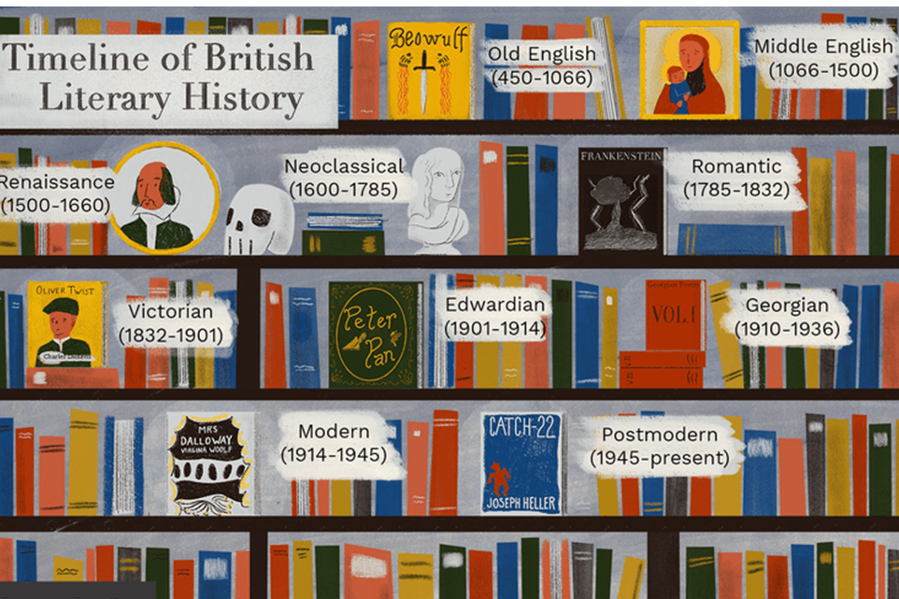
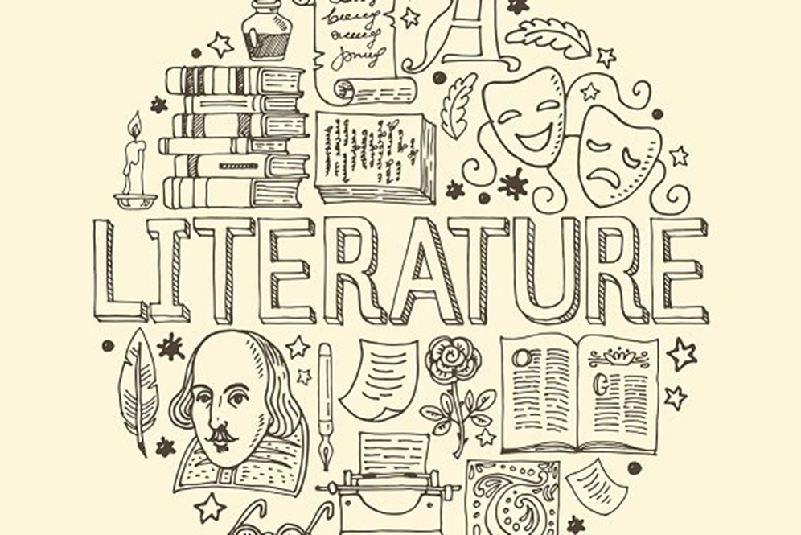

Well done – you are thinking about studying a wonderful enriching subject. A level literature is a combination of poetry, plays and novels from different centuries.
In order to prepare for Y12 you should :
Read a book – either Brave New World by Aldous Huxley or Fahrenheit 451 by Ray Bradbury (or both!)
https://archive.org/stream/ost-english-brave_new_world_aldous_huxley/Brave_New_World_Aldous_Huxley_djvu.txt
OR
https://www.fsusd.org/cms/lib03/CA01001943/Centricity/Domain/2034/Fahrenheit%20451.pdf
- You do not have to buy these books – both are available online in pdf.

- Whilst reading make notes of themes and issues covered throughout. Consider the characters and their role in the action.
  - Write a short review for fellow teens.

Listen to a book – Stillicide – bbc.co.uk has a performance of this book by many readers – this is available for nothing for the next 140 days!
https://www.google.com/search?q=stillicide+radio+4&rlz=1C1CHBF_enGB875GB875&oq=stillicide+&aqs=chrome.2.46j69i57j0l5.6532j0j9&sourceid=chrome&ie=UTF-8
TASK:
Whilst listening make notes about the future world in this story. Is it a recognisable future? Explain.
Does it have characters you can identify with? Who? Why?
Learn about a new Shakespeare play – e.g. not Macbeth or Romeo and Juliet
Audible have made a range of stories and plays available for nothing. There are many sections. You need to go to Discover Literary Classics – there are absolutely brilliant books there (including Brave New World). Hamlet and The Tempest are both available for you.
https://stories.audible.com/start-listen
Project Poetry – Make your own anthology. Choose a theme you really care about – for example: isolation; identity; love; nature; loss; joy; war; childhood (choose any theme).
Make your own anthology of poetry connected to your chosen theme. Choose a range from 15th – 21st centuries e.g. - Chaucer – Shakespeare – Edna St Vincent Millay - Donne – Browning – Owen – Dickinson - Plath - Hughes (any poets you liked from your AQA anthology). Give your anthology a title. Write about how you chose your poems.
AT ECKINGTON WE SIT THE OCR EXAMINATION BOARD- IF YOU WISH TO CHECK OUT THE SPECIFICATION FURTHER

